Mid-term student survey results (32 responses)

* I am getting value out of this course that I anticipate being useful in my professional career.

**Score =4.7**

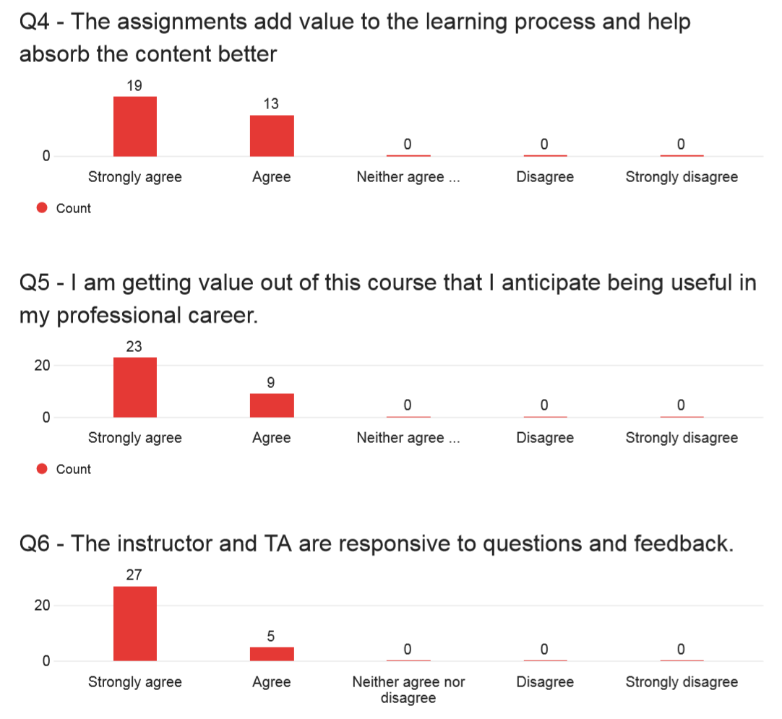

(5) (4) (3) (2) (1)

* The instructor and TA are responsive to questions and feedback.

**Score =4.8**



(5) (4) (3) (2) (1)

* I am satisfied in challenging myself to achieve education objective and help the class learn from each other by participating in group discussions.

**Score =4.6**

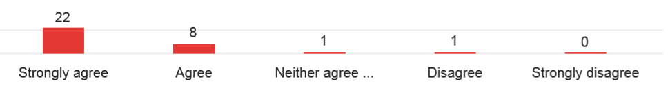

(5) (4) (3) (2) (1)

* The course lecture videos are a useful aspect of this course.

**Score =4.7**

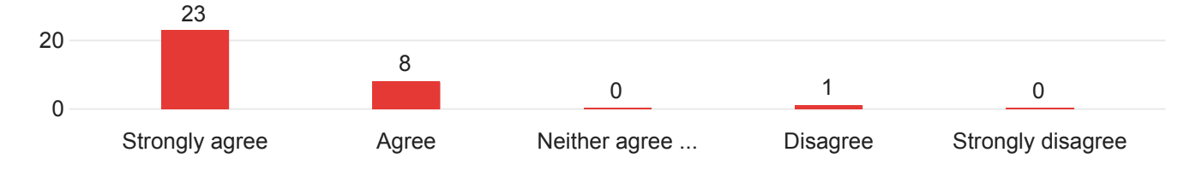

(5) (4) (3) (2) (1)

* The course discussion forums are a useful aspect of this course.

**Score =4.1**

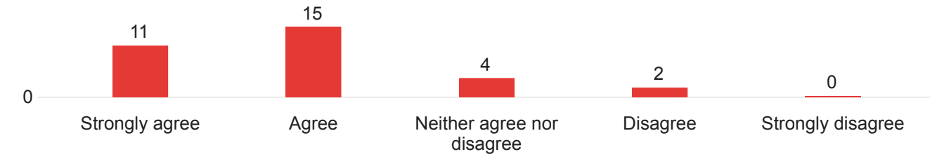

(5) (4) (3) (2) (1)

* The textbook readings supplement the videos and help understand the course better.

**Score =4.2**

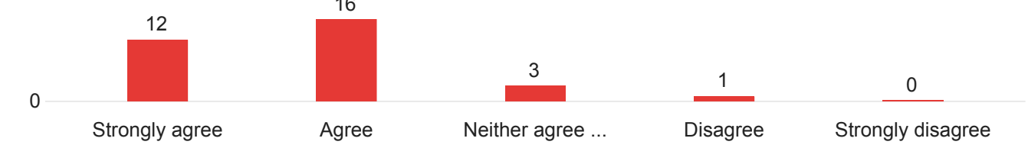

(5) (4) (3) (2) (1)

* The assignments add value to the learning process and help absorb the content better.

**Score =4.6**



(5) (4) (3) (2) (1)

Any other comments / feedback

* Videos help me to understand how to make decisions and how great companies has been established. Also, I like the negotiation simulation.
* I have enjoyed the class vey much. It is very dynamic which helps us learn the material more effectively.
* Thank you for the work that you put into the course. It shows.
* First and foremost, this course is paramount for future industry leaders. The content is great for mid-level careers.
* I wish things were planned out a bit more in advance and made available to us. This would allow us the opportunity to work ahead if needed (e.g. work travel or holiday)
* This class has been amazing; I've enjoyed the videos, the practices, specially the decision tree and simulation.
* Profession seems very easy to communicte and open for all suggestions.
* This course, the instructor and TA are exceeding my expectation.
* The course material is designed such as to promote effective learning including the hands on practice of the concepts learnt.
* Dr. Yang and Pratima are sensitive and accommodating to the student's issues, work and professional commitments and create an environment to nurture effective systematic learning.
* This is my favorite course both in terms of content and faculty associated. Thank you for such a well-designed course that stands up truly for the spirit of graduate degree for working professionals.
* I cannot emphasize how much I’m learning in this class and also applying to my job strategies. I do not regret taking this class and I am extremely satisfied with the curriculum, professor and TA.
* I really enjoy this course, as I am being exposed to tools and techniques that I have never seen before.
* Thank you for the learning opportunity.
* The only change I would recommend is to make the discussions over actual industry examples for the respective module. And the discussion submissions should be voluntary rather than mandatory.
* Consider adding some case studies/stories (good and bad scenarios) for analyzing. I don’t have all the answers here but will try to provide some insight rather than just complaining. Discussion forums are a challenge getting people to feel more comfortable to interact. I believe we have more to learn from each other. I believe some of the discussion board barriers may be related to the tone set for discussion forums. What is our main objective? To make formal graduate posts or to get graduate students to relax a little and feel comfortable sharing experiences. Putting myself in the shoes as a professor I would want students to feel comfortable to discuss like a hang out. Some of us get on FB and some are starting to have separate meetings based on our assignment groupings. I wonder how discussion forums would be if we had more of these interactions there on the FBs. Thank you for your consideration!
* The videos are painfully boring to watch and listen to, and split into 20-30 videos per Module which is cumbersome and unnecessary. It takes a great deal of time to download each video transcript so you can create one cohesive file of notes & print the entire Module. For example, Handy's lecture is a single video and one transcript to download and print. I don't need to piece together 30 lectures with slides so I can print & read while I travel. I like printing my notes on paper so I can highlight and make my own notes. The format in which the videos download into are a massive waste of space and paper; I must compress all of the text into a Word doc in order to create one set of notes for each module. Also, the outside reading material could be much improved. Perhaps assign books for us to read that are not so dry.
* It would be nice if the videos are combined to be each 15 mins long.